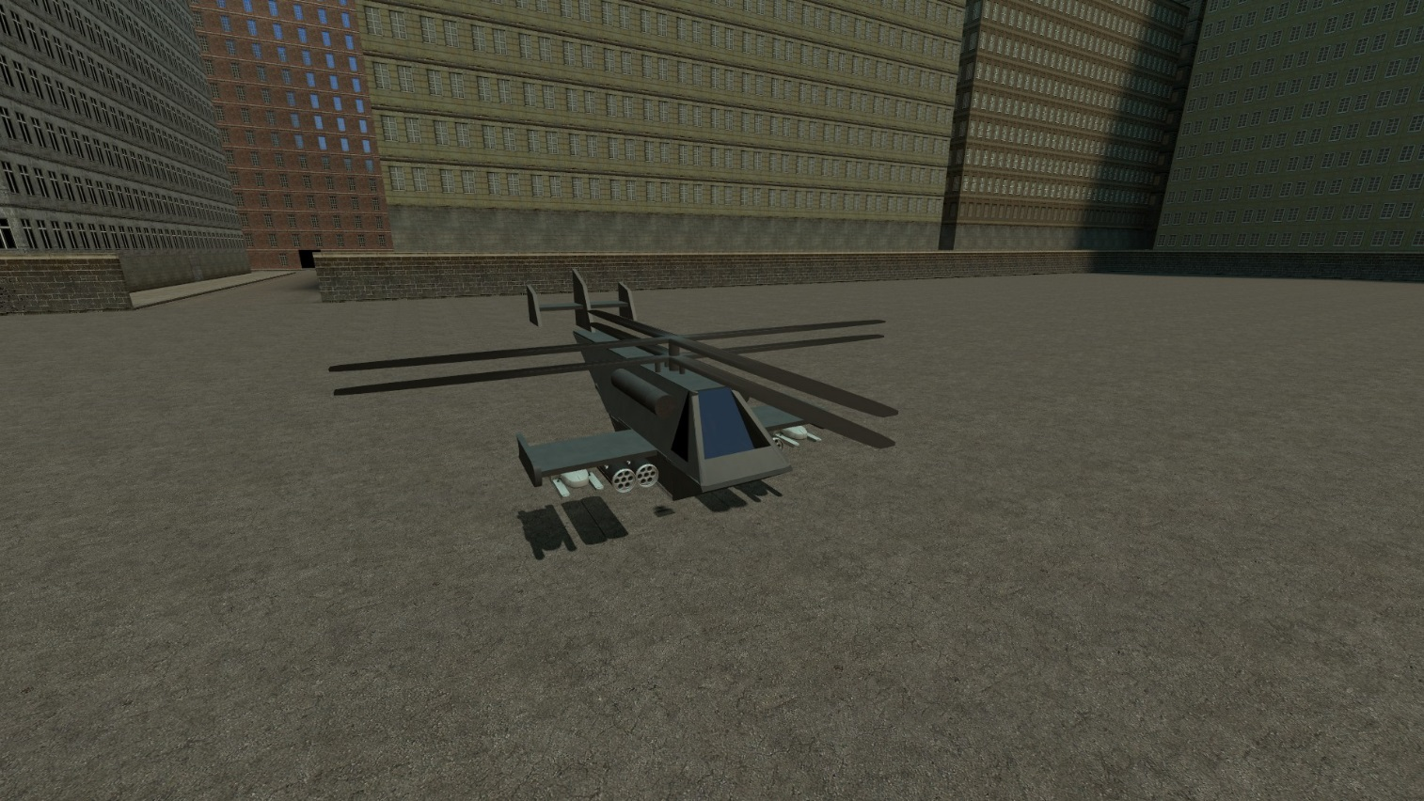
Dark Eagle AT

Description:
Fast and agile helicopter armed with 4 Hellfires and 4 ZUNI pods. Hellfire locks to the nearest vehicle (including chairs) to the helicopter with player driving it. Based on 1st helicopter I’ve built
Controls:
- Hold Alt (Default walkbutton) – camera will change to 1st person
- Center the camera
- Hold Alt again to 3rd person
- Press F (Flashlight) to startup

Mouse – General control. Look left to turn helicopter left, look down to nose down etc
W/S – Ascend/Descend
A/D – Strafe left/right
LMB/RMB – launch hellfire from left/right rack
Shift – shoot unguided rockets
R – Reload

MV 88 AT
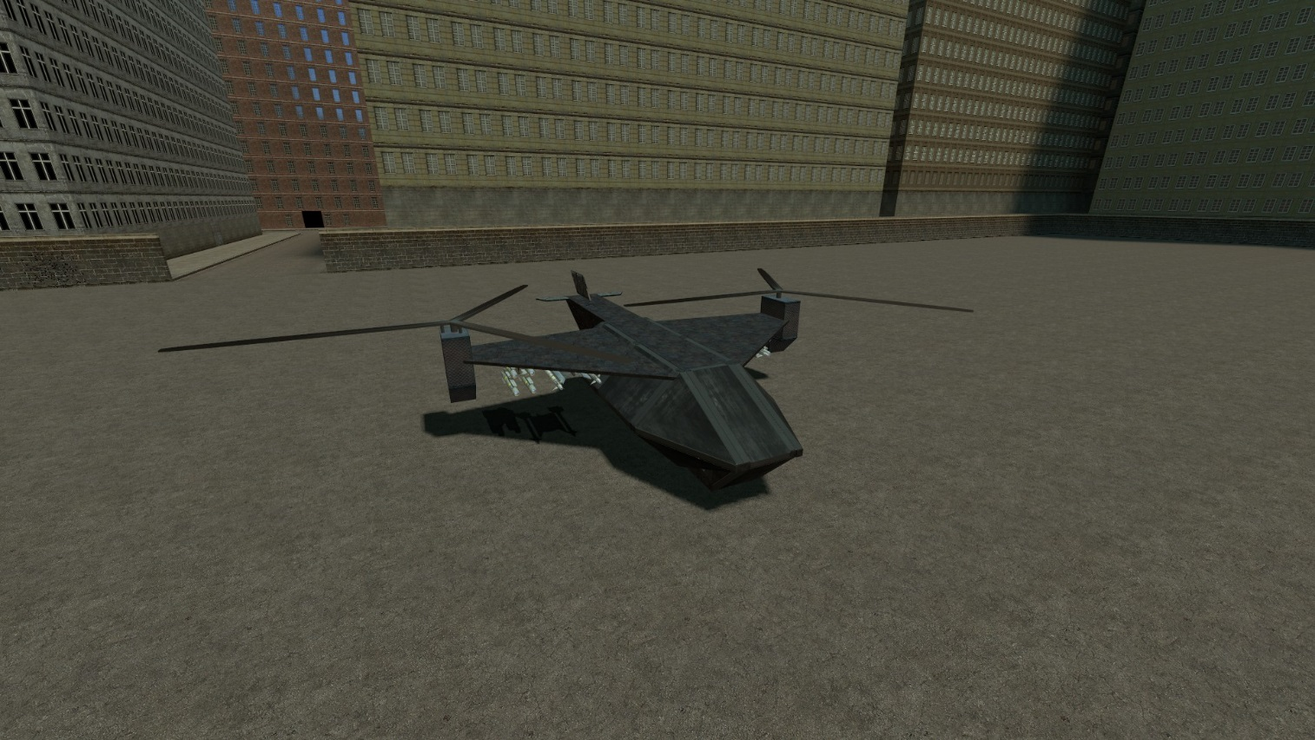

Description:
Heavy version of Dark Eagle AT. Armed with 8 Hellfires and 4 AA missiles
Controls:
- Hold Alt (Default walkbutton) – camera will change to 1st person
- Center the camera
- Hold Alt again to 3rd person
- Press F (Flashlight) to startup

Mouse – General control. Look left to turn helicopter left, look down to nose down etc
W/S – Ascend/Descend
A/D – Strafe left/right
LMB/RMB – launch hellfire from left/right rack
Shift – shoot 2 AA missiles
R – Reload

